Quarterly Macro Fiscal Model (QMFM)
Quarterly Macro Fiscal Outlook—Sept 2024 Forecast: Summary & input for intMF (Oct.7)
As set out in the Feb. 2024 Mgt Brief, the purpose of the QMFM model and this summary is to provide SMT forecasts and scenarios for key macro aggregates (12-16Q), which can feed the intMF and IMF review discussions. The QMFM provides an independent assessment of the interactions of fiscal, monetary, and ER policies, external developments, and trend changes in their determination of real GDP, prices, final demands, RER and RIR, and other variables. The demand-driven forecasts—with a key role in fiscal policies— complement projections of IntMF that are mainly supply-driven.
I. Initial conditions
Assumptions: Sep. IMF WEO-GAS/GEE; US RIR projection CBO; NBR’s monetary and ER policy rules.
Baseline fiscal policies are as in PCI 2023/24-2025/26, followed by a return to the previous path of gradually moving toward a sustainable deficit of 5% of GDP (7.5% excl. grants) rather than 3% as in the post-PCI IMF projection. This note deems such a path as preferable to excess fiscal consolidation.
Data: given persistent and new anomalies in NISR NA final-demand data for the past four Qos, these had to be ignored and replaced by model estimates to get plausible initial conditions for the forecast.
II. Outlook—baseline scenario
1. real GDP is forecast to slow down markedly in 2025-26, well below potential growth, followed by a catch-up (a bit above potential) in 2027-28, before returning to the regular growth path of 7½%.
GDP growth in 2024 is forecast at 8% despite a slowdown to 5% in the last Q, given robustness earlier in 2024. Growth so far in 2024 was helped by still low RIR (below trend) and still modest fiscal restraint. Does it add value to mention that the effect of lower RIR—is transmitted thru lower lending rates) and highlight the effect of low RIR (lower lending rates—r4_gap) in consumption (GDP gap is mostly driven by the consumption gap) in 2024.
The slowdown in 2025-26 is driven by:
- contractionary effect of strong fiscal consolidation, both directly as govt demand for G&S falls, and indirectly through the negative fiscal impulse on private demand
- negative impact on demand of increased RIR as the real lending rates return to normal
- slightly offsetting positive, but lagged effect on net exports of recent and further RER depreciation
The catch up in 2027-28 is driven by:
- end of fiscal consolidation, the negative fiscal impulse stops
- end of increase and the start of a slight decrease in RIR
- positive impact of more depreciated RER (some undervaluation)
==>for intMF projection GDP growth p.a.: 2024: 8%, 2025: 5%; 2026: 6%, 2027-28: 8-9%, 2029: 7.5%
2. CPI is forecast to be subdued, below 5% through 2027, followed by a gradual return to target 5%
The y-o-y and period average CPI in 2024 should be below 5%, helped by a recent drop in food prices, a reversal in 2023-24 of earlier positive price shocks, and expectation of lower inflation thanks to demand-restraining policies.
The CPI well below 5% in 2025-27 is driven by:
- effect of increasing RIR and large negative fiscal impulse on demand, hence output
- continued drop in food prices as agriculture returns to normal
- still low trading partner prices, and a small drop in world energy and food prices
- somewhat offset by the CPI-increasing effect of NER depreciation on import prices
The return to the target CPI from 2028 onward is driven by:
- govt demand pick up (as consolidation stops post-PCI)
- other demand components return to normal
- interest rate policies push inflation back to target
==>for intMF projection CPI p.a.: 2024: 4%, 2025: 5%; 2026: 4%, 2027: 3%, 2028: 4%
3. Final demand: private demands are forecast to slow down in 2025-26, returning to normal thereafter
Real consumption: after above-trend growth in 2023/early 2024, restrictive policies lower real consumption growth to +4% in 2025-26, before it returns to trend growth in line with GDP (7.5%)
Real investment: after sluggish growth in 2022-23, growth is forecast to be strong in 2024 (above 10%), slowing down to +6% in 2025-26 as real lending rates increase; then moves to trend growth
Real exports: after above trend growth in 2023-24, export growth slows down but gradually as the positive effect of recent RER depreciation keeps export growth above trend the whole period
Real govt demand: almost no growth in 2025-26 due to fiscal consolidation, strong pickup thereafter
Real imports: follow other demand components (including govt demand)
==>for intMF projection: adjust exogenous investment growth and revisit export & import projections, while verifying residual private consumption growth to make it in line
4. Fiscal path assumed: PCI targets FY2024/25-2025/26 for deficit, revenue, and spending are set
- negative govt demand and fiscal impulse entail growth slowdown in 2025-26
- from late 2026, negative fiscal impulse ends, deficit moves back up toward sustainable path
- the beyond-PCI sustainable fiscal ratios toward, rev/GDP 24%, govt dem G&S 26%, other exp 5.5% grants 2.5% and debt-creating deficit 5% of GDP (consistent with 45% NPV public debt)
- esp. as revenue is slow to rise, debt-creating deficits are for a few years above sustainable, at 7%
==>for intMF: revisit post-PCI fiscal path, in line with move to sustainable debt and deficit levels
5. ER: returns gradually to path of only correcting for inflation differentials (2% py)
- recent real overvaluation (mostly from 2022-23 inflation episode) has already been more than corrected with NBR's 2023-24 steep depreciation
- QMFM projects return to ER policy rule (mostly moving with inflation differentials), no need for further RER depreciation
- PCI, instead, "poses" lingering overvaluation of 15% (which evidence?) requiring more depreciation, as built into PCI projection 2024-28
==>for intMF: ER depreciation can slow down, with less need for intervention (note that RSF and SCF should not be excluded from reserve coverage, nonsensical esp. as all RSF was channeled to budget)

6. RIR lending rate: expected to go up to normal (around 12%, for 8% margin above IB rate), but remain above pre-Covid level as world RIR projected to reach 1.5% (from negative in recent years)
- RIR lending rates have been low (below trend) during most of 2022-24 though they have been rising in recent quarters (as inflation fell)
- as they are now returning to normal, their demand-stimulating effect is ending and reversing
- the neutral policy (IB) rate—after a temporary drop with low inflation--is expected to go up to 8.5-9% (and 4-4.5% in real terms) as world RIR increases and CPI inflation returns to target

Table 1. GDP, CPI, and final demands
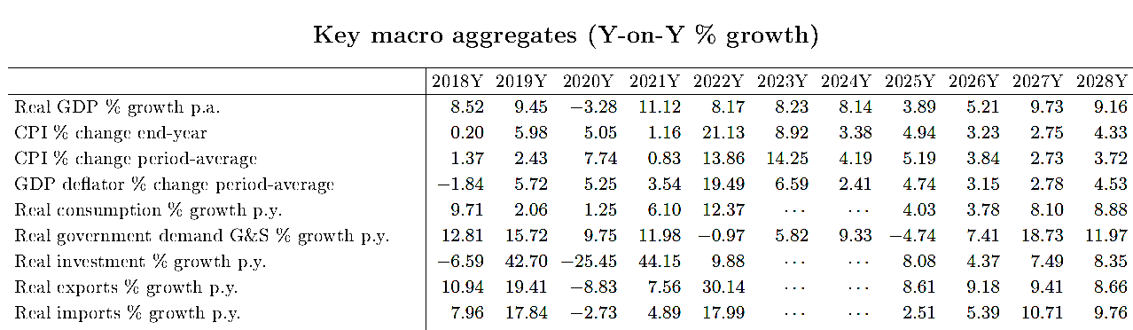

Chart 1. GDP (y-on-y) | Chart 2. CPI_headline (y-on-y) | Chart 2A. CPI_core (y-on-y)
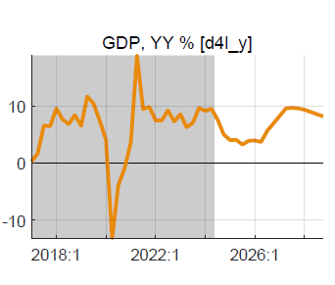 | 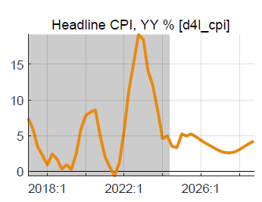 | 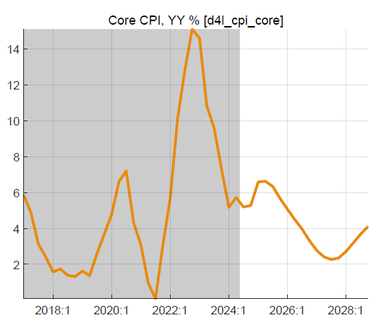

Chart 3. Real final demands (y-on-y) growth
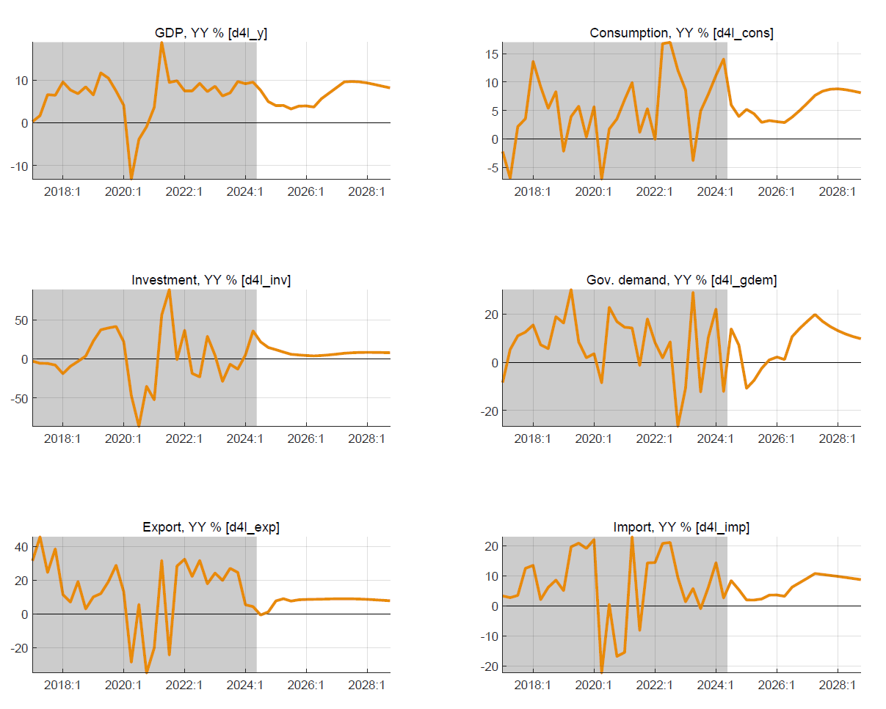

Chart 4. Fiscal aggregates (2024/25-2025/26 PCI)
Budget deficit (before grants, GFS1986) | Government demand for G&S vis-à-vis trend
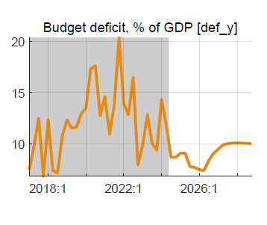 | 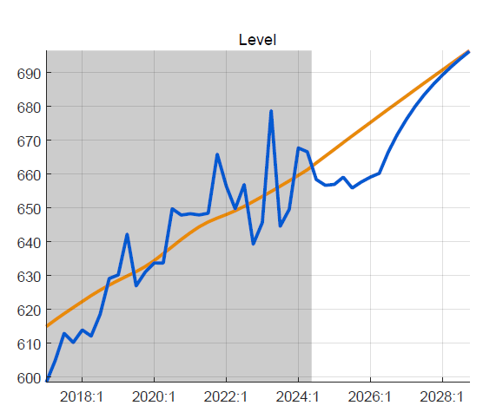
Government revenue, % of GDP, vis-à-vis trend | Fiscal impulse (discr. def. & change structural def.)
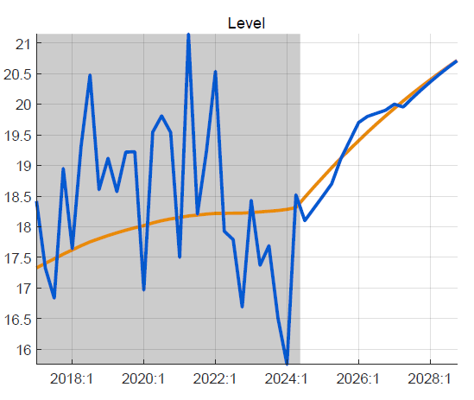 | 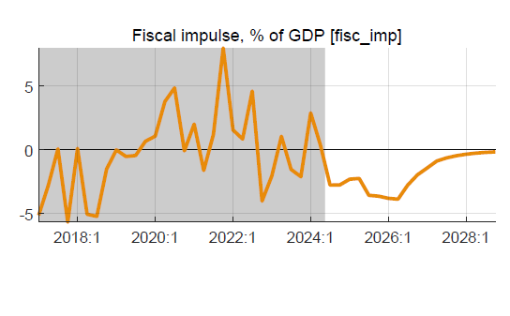

Chart 5. Real and nominal exchange rate
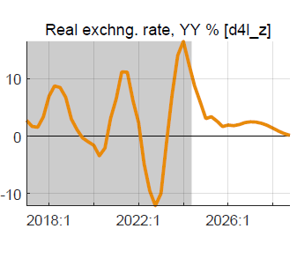 | 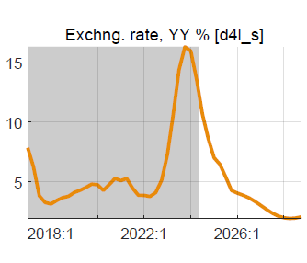

Chart 6. Real and nominal interest rate
Real lending rate relative to trend, % | Policy rate (IB) and neutral rate,% | Trend in US RIR (CBO), %
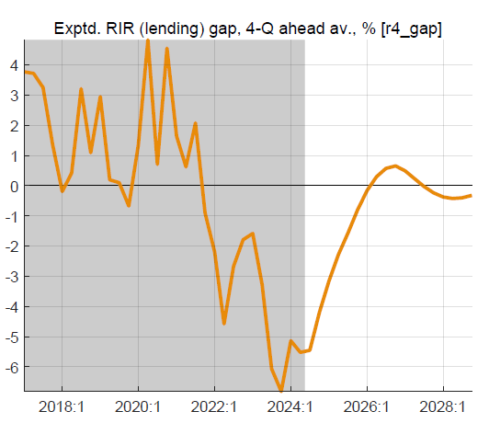 | 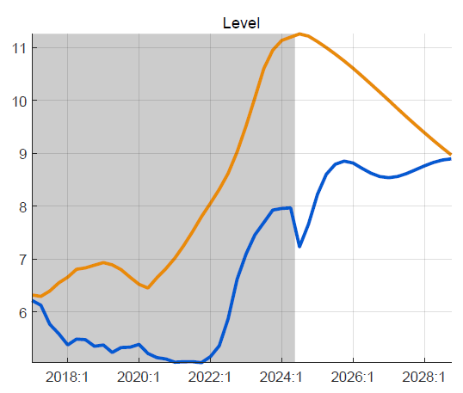 | 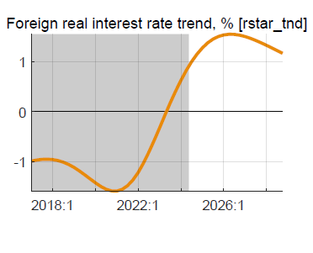

Table 2. Key macro aggregates, annualized
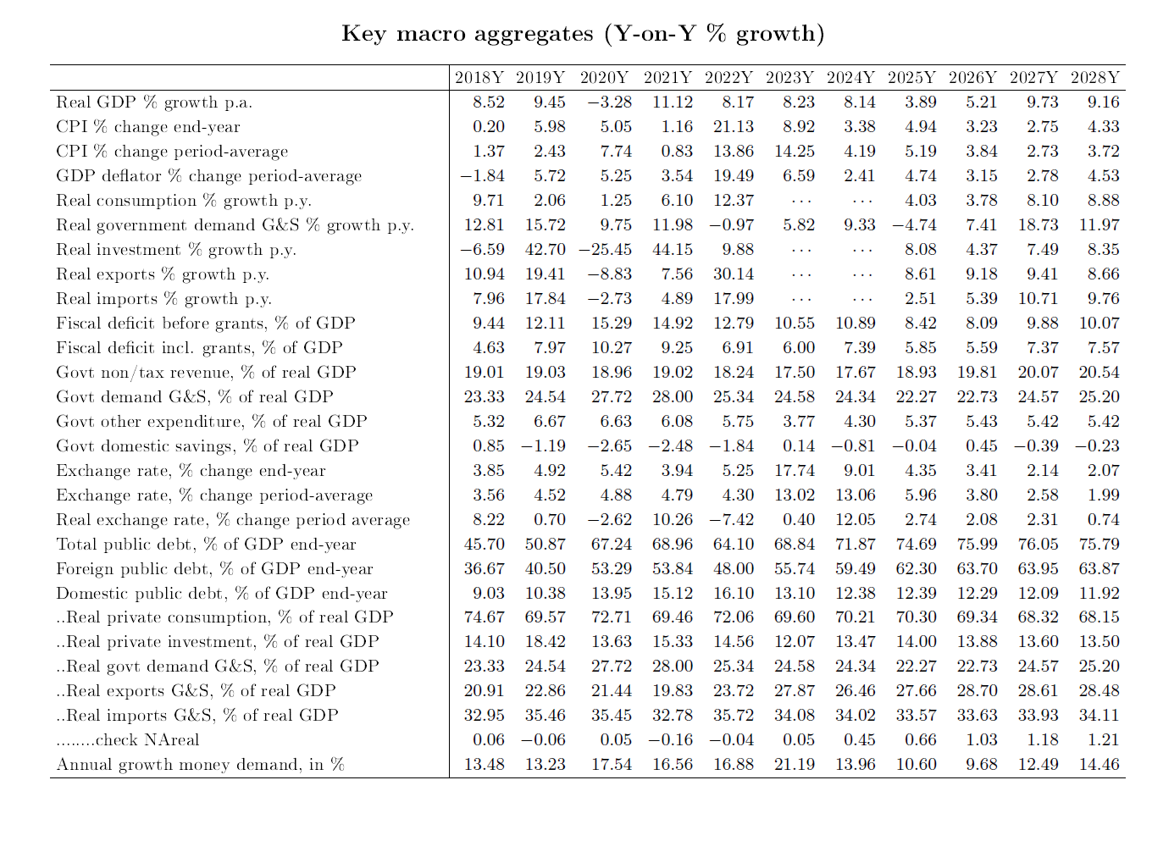

A debt-creating deficit of 5% of GDP corresponds—under realistic assumptions on growth, trading partner CPI, share of domestic debt, concessionality external debt—to a sustainable debt-GDP ratio of 45%, well below IMF-DSF’s ceiling of 55%.
An alternative fiscal scenario, with post-PCI fiscal targets as in program FISCAL, has unrealistic leaps in revenue, an even larger GDP growth slowdown effect, and an even sharper drop in debt/GDP than the Baseline.
The neutral policy interest rate comprises the trend RIR, which includes world RIR, country risk premium, and expected RER depreciation. In the forecast period, the latter pushes up the neutral rate by about 2% points.

